1. File preparation
A dxf file named “DF_XXX.dxf” (XXX stands for the ID of the board) should be provided for each board. The content is illustrated here:
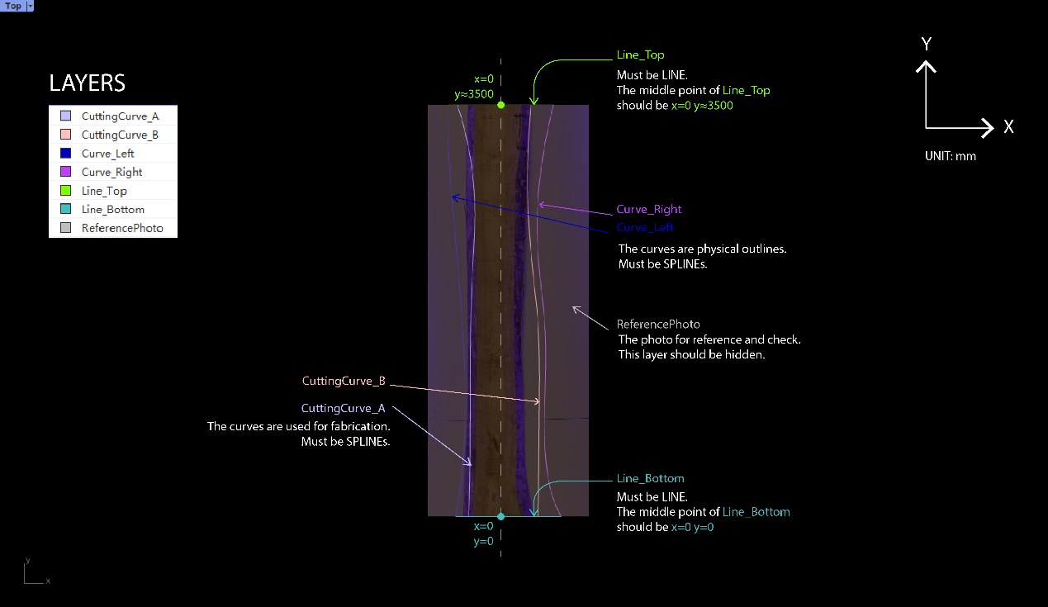
The exact content example without any illustration is shown here:
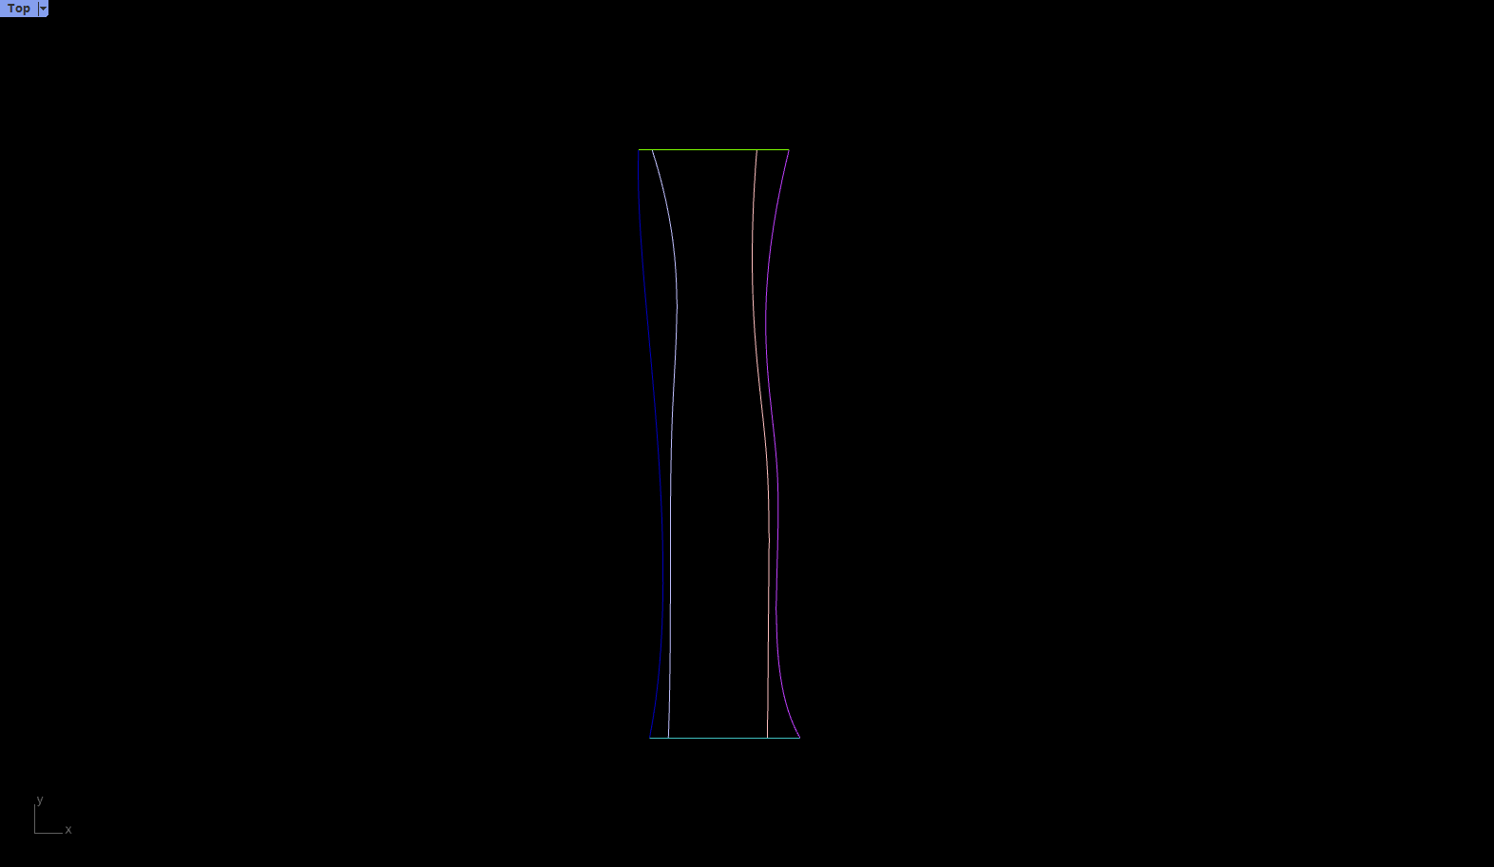
The example dxf file is attached.

2. To do List
- Existing Curve - Simplifying
- Cutting Curve - from Algorithm Team
- Image - from Imaging Team

- Layer Setup - Almost
- Reference photo - Almost
- Rescaling
- Align

